Let’s play this magical game!

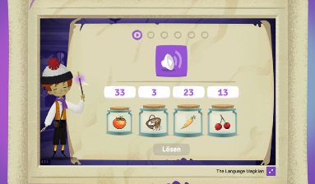
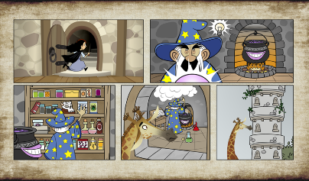

Look! Let’s play a fantastic game!
You have to answer questions to help some animals.
You have 35 minutes to play the game.
Let’s see who can reach the highest level!

1. Open this Internet website https://game.thelanguagemagician.net/ or scan this code:

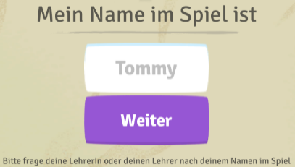
2. Enter the code and click on OK.

3. Enter your name and click on Weiter.

4. Pick your avatar and wait for your teacher to start the game.

Good luck and enjoy the game!

